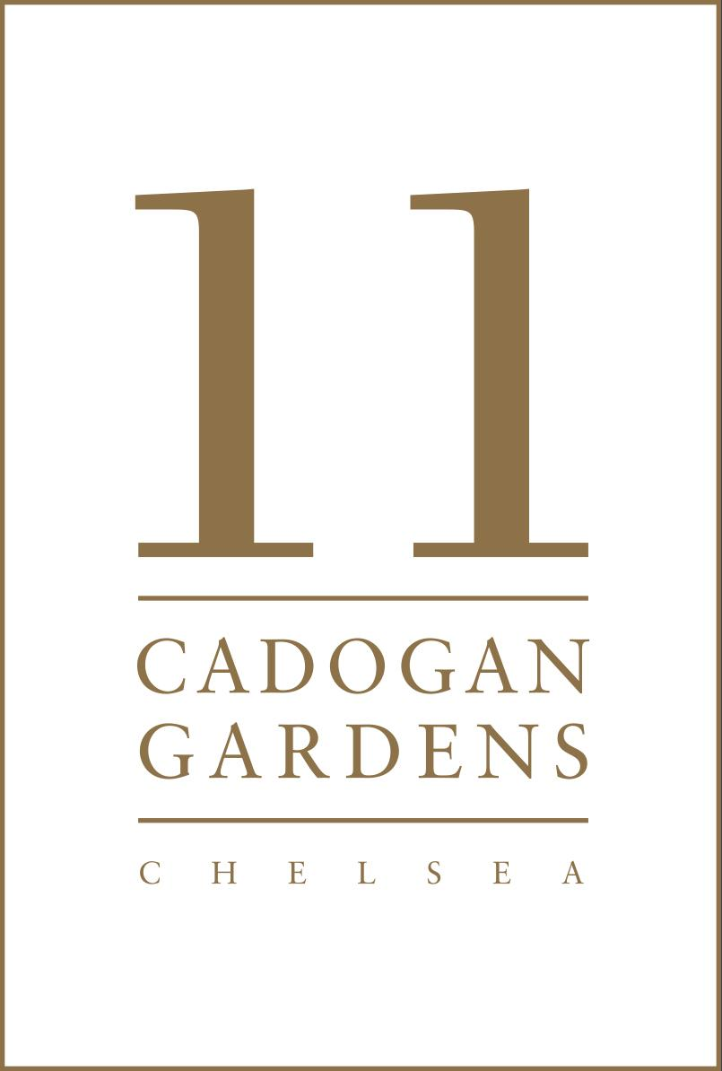

FACT SHEET
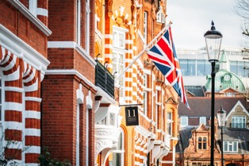
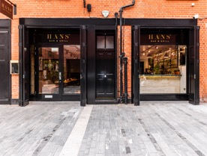
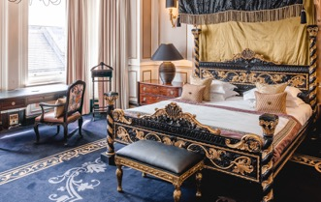
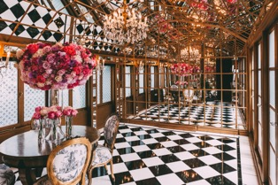

Media Contacts:

J Public Relations Iconic Luxury Hotels
iconic@jpublicrelations.com angela@iconicluxuryhotels.com

Telephone | +44 020 7730 7000
Website | www.11cadogangardens.com
About | Built by Lord Chelsea in the late 19th century and originally composed of four separate Victorian town houses, 11 Cadogan Gardens is an unforgettable boutique hotel in the heart of Chelsea. Throughout its many corridors, the hotel has 56 guest rooms, including 25 suites that have been designed to be as memorable as they are luxurious, each completely different. The hotel is home to a Drawing Room, Chelsea Bar, and the Hans’ Bar & Grill restaurant. Adorned with a traditional Victorian façade and a belief in tradition, heritage, and intrigue, 11 Cadogan Gardens is an unmistakably unique hotel not to be missed.  11 Cadogan Gardens was the first Relais & Châteaux hotel in London; an exclusive collection of 560 of the finest hotels and gourmet restaurants in 55 countries. Established in France in 1954, the association's mission is to spread its unique art de vivre across the globe by selecting outstanding properties with a truly unique character. It was 11 Cadogan Gardens’ sister-hotel, the award-winning Chewton Glen, that set the standard of excellence for Relais & Châteaux in the United Kingdom, as the first-ever British hotel to join the association back in 1971. 11 Cadogan Garden joined in 2019, becoming London's first Relais & Châteaux hotel member.
Location | 11 Cadogan Gardens is in the heart of fashionable Chelsea, just moments away from Knightsbridge. A desirable location for guests who want to explore the destination by foot, the hotel is in close proximity to London’s finest boutiques, bars, and eateries. It is situated in Sloane Square, London’s most aspirational shopping district, home to the world’s top brands and fashion powerhouses such as Prada, Chanel, Tiffany’s, and Hermes, as well as Harvey Nichols and Harrods.
History | Built by Lord Chelsea in the late 19th century, 11 Cadogan Gardens originally comprised four separate Victorian town houses. This helps explain the myriad of corridors, staircases, and hallways throughout the hotel, and why it is not uncommon to find a bemused guest wandering the corridors having taken a wrong turn.  With a fabulous location in such a prestigious area, the hotel became vastly popular as a home from home for travelling Victorian aristocrats, politicians and bon viveurs. In that progressive era, the area was known as something of a bohemian quarter, attracting notable personalities including radicals, artists and poets.  11 Cadogan Gardens was also at one time home to a private members club, and a sense of privacy and exclusivity remains. If our walls could talk, we feel sure they would regale us with tantalizing tales and glamorous gossip from days gone by.  We would like to think that we are still an intriguing destination for discerning clientele. Our distinctive style is unparalleled, and we are proud to serve our guests to the highest possible standards. Intriguing, evocative and unmistakably unique – we urge you to discover 11 Cadogan Gardens for yourself.
Architecture/ Interior Design | The property has a Victorian façade, which denotes its tradition and heritage. Inside, it is said to have one of the most distinctive interiors in the capital. Its unique style is evident from the moment you are greeted. Opulent, dramatic, and decadent are the style cues that echo throughout the hotel.
Accommodation | 11 Cadogan Gardens is home to 56 hotel rooms including 25 suites. Each distinctly designed to exude the rich heritage of the hotel, no two rooms are alike. 11 Cadogan Gardens offers seven types of rooms, The Sloane Suite, Cadogan Suites, Signature Suites, Junior Suites, Deluxe King Rooms, Superior Queen Rooms and Petite Double Rooms. Throughout the suites, warm palettes with traditional accents of vibrant colour, ornate dark wood fittings paired with bold metallic finishes, and eclectic décor can be found. A gem in the crown of 11 Cadogan Gardens, the lavish 120sqm Sloane Suite is one of our guests most favourite suites. Overlooking Cadogan Gardens, the suite is adorned in a distinct palette of regal gold, cream, and black finishes tied together with a grand four-poster bed. The hotel’s bathroom amenities are by Noble Isle, an exquisite, fine fragrance bath and body brand, inspired by the natural and cultural riches of the British Isles.
The Apartments  by 11 Cadogan  Gardens | Launched April 2021, The Apartments by 11 Cadogan Gardens combine the luxury of fully serviced apartments with the discretion, comfort and security of a private residence. The newly renovated six-storey historic townhouse offers a completely new style of accommodation to the hotel’s existing rooms and suites.  Located a stone’s throw away from the main hotel across the leafy, private Cadogan Gardens, The Apartments are ideal for families thanks to their expansive footprint and multiple-bedroom options, whilst the fully fitted Bosch kitchens and opulent living areas means that they are the perfect choice for laid-back luxurious extended stays in a desirable London neighbourhood. Whether staying for two days or two months, for business or pleasure, The Apartments by 11 Cadogan Gardens offer both keys to the city and the perfect retreat.  Set behind a red brick Victorian façade, The Apartments by 11 Cadogan Gardens consist of six floors, each home to a one, two or three-bedroom elegant residence (six apartments in total). The effortlessly stylish spaces designed by Atellior architecture and interior design studio nod to the Victorian architecture of the existing building and its heritage, mixed with contemporary furnishings and modern décor. Much of the design inspiration has come from the property’s location and neighbouring Chelsea Flower Show, with botanical wallpapers and aptly themed Taschen books throughout. In addition, each apartment enjoys views over, and access to, the exclusive Cadogan Gardens and are entered via a secure and private off-street entrance with direct elevator access. Prior to arrival, fridges are stocked with essentials and home comforts.
Food & Beverage | Hans’ Bar & Grill: 11 Cadogan Gardens opened Hans’ Bar & Grill on Pavilion Road to deliver a delicious all-day service in a calm and rejuvenating oasis- like setting. All menus, from breakfast to brunch, lunch, and dinner, are rooted in local British produce. The all-day dining menu is full of delicious dishes with some punchy, spicy flavours, fresh fish from the South Coast and great British Beef in addition to a concentration on plant-based foods.  Set on the pedestrianised Pavilion Road, Hans’ Bar & Grill offers alfresco dining – perfect for morning coffees – or come inside to the eminently charming café bar and all-day dining restaurant for health-boosting lunches, cocktails with friends and memorable family dinners.  The wine list is extensive, bursting with old-world favourites as well as new world wines waiting to be discovered. With regular wine tasting events held in the Wine Room, join Hans’ on the famous Grill Nights and their knowledgeable team will gladly help you pair your wine choice and dinner perfectly.  Private dining is available in both the Curio Room and Wine Room. It is your new neighbourhood hang out for every occasion and the perfect addition to Pavilion Road’s foodie scene.  Drawing Room: Flooded with natural light, the Drawing Room is a classical surrounding for afternoon tea. Served fresh every day, created from a blend of seasonal fresh, dry, and infused flowers and herbs, the tea is paired alongside traditional finger sandwiches, freshly baked scones, and delicate pastries as quintessentially British as can be. For a truly celebratory experience, the finest selection of Champagnes is served as well.  Library: A real treat for the literary traveller, the Library houses an extensive collection of historic and antique books, some dating back to the mid 19th century. Settle into the plush sofas for an afternoon of literary exploration into the tomes of Shakespeare, Dickens, and beyond.  The Chelsea Bar: The Chelsea Bar is a wonderful setting for a restorative cocktail after a taxing day exploring the boutiques and department stores of Chelsea and Knightsbridge. It is unashamedly moody and seductive with a dramatic colour palette of gold and charcoal. The house cocktail menu blends traditional favourites with innovative mixes marrying exclusive vintages, limited edition Champagnes, spirits, and liqueurs. There is also an extensive wine list and a selection of beers along with a menu of light bites.  Private Dining: The boutique venue of 11 Cadogan Gardens is one of the most versatile spaces in London and offers a myriad of rooms for private dining, with the option of both inside and out.
Meetings & Event Space | 11 Cadogan Gardens is ideally suited to corporate events when guests need to make a lasting impression on colleagues and clients alike. The property offers a versatile space to act as the setting for major events such as engagements, family occasions, and exclusive get togethers.  The Library: Subtle lighting, plush sofas and historic portraits create a wonderfully relaxed environment to while away the hours undisturbed (capacity 15).  The Chelsea Bar: The bar is unashamedly moody and seductive, with a dramatic colour palette of gold and charcoal. It is a theatrical setting in which to kick back, entertain and be entertained (capacity 50).  The Mirror Room: The mirror room is an opulent room adorned with lashings of gold and a surrounding of mirrors. The room interconnects with two suites which will be included when hiring this room for a private event (capacity 15).  The Curio: This delightful room benefits from natural daylight and its own private entrance from leafy Cadogan Gardens. The Curio adjoins to The Curio Lounge, a private and flexible space perfect for pre-dinner drinks or a break-out room for meetings (boardroom – 16, reception – 25, dining – 18).  The Wine Room: Our Wine Room is a beautiful glass fronted wine cellar, showcasing our extensive wine collection. This semi-private room connects to Hans' Bar & Grill, allowing you to soak up the buzz of the restaurant whilst enjoying privacy (dining – 22 on 3 separate tables or 15 on one table).  The Conservatory: A serene environment for an intimate meeting or dinner. The conservatory connects to the drawing room and has access to the secluded outside terrace, therefore, although the room offers a lovely little spot, it is not ideal for guests who require complete privacy (capacity 6).
Amenities/ Services | - 24-hour gym access  - 24-hour room service  - Access to the private Cadogan Gardens  - Air conditioning  - Afternoon tea  - Bar (The Chelsea Bar)  - Bathrobes and slippers  - Bathroom amenities by Noble Isle  - Complimentary WiFi  - Concierge  - Hairdryer  - In-room safe  - Iron and ironing board  - Library and lounges  - Nespresso machine and bottled mineral water  - Newspapers  - Private meetings, events and dining rooms  - Restaurant (Hans’ Bar & Grill)  - Ruark DAB radio and Bluetooth speaker  - Samsung LED TV with satellite channels  - Telephone  - Welcome amenities
Neighbourhood | Guests looking for a little more can wander just a few moments to discover the characterful Pavilion Road, London’s longest mews that runs parallel to Sloane Street, also the place for artisan food and drink. Formerly Victorian stable blocks, the road has seen a complete transformation and is now a picturesque haven for independent artisans, from butcher and baker to grocer and cheesemonger (and three restaurants).  11 Cadogan Gardens’ prime location offers so much to those keen to explore the best of Chelsea, Knightsbridge and Belgravia. Just a short stroll away is Sloane Street, internationally recognized as one of the world’s most exclusive and luxurious shopping destinations. From there, Harrods, the world’s leading luxury department store awaits. Also nearby is the world famous King’s Road, which has been a place to saunter, sip and shop since 1830, today home to some of the best independent and high street stores, from Peter Jones, The Fashion School and Anthropologie, along with fantastic restaurants such as Rabbit, Zuma, and The Ivy Asia Chelsea Garden.  Several cultural attractions within walking distance include: Cadogan Hall, Chelsea Physic Garden, Saatchi Gallery, The V&A, The Natural History Museum and more. For those keen to discover the neighbourhood on foot, there are several self-guided walking tours to be taken from the doorstep of 11 Cadogan Gardens, including “Literary Chelsea” and “Instagrammable Places”. Meanwhile, those looking for green spaces can enjoy the beautiful nearby parks including Kensington Gardens, St James's Park and Hyde Park. For families, the hotel can provide tickets and recommendations to all the greatest spots in the city without the worry of little VIPs having to wait in a queue for a long time, from the studios of Harry Potter to London's Zoo in Regents Park.  Pavilion Road (0.1 mile): Step out of our restaurant, Hans' Bar & Grill, to discover Pavilion Road, London's longest mews. Lined with Victorian era stable blocks, the road is now a picturesque haven for independent and artisan food, beauty and fashion stores. It is also completely pedestrianised and has become home to several restaurants and bars, offering alfresco dining. It also features the 'Edible Trail' to promote urban gardening and sustainable gardening principles; residents and visitors alike are encouraged to try their hand at foraging and experience sustainably grown produce.  Sloane Street (0.1 mile): internationally recognised as one of the world's most exclusive and luxurious shopping destinations in London  The Saatchi Gallery (0.2 mile): housing one of the country’s greatest contemporary art collections.  Cadogan Hall (0.2 mile): the permanent home for the Royal Philharmonic Orchestra.  Harrods (0.5 mile): seven floors and 330 departments of the finest luxury merchandise, from haute couture to pet accessories.  Chelsea Flower Show (0.6 mile): the world’s most prestigious flower show that inspires millions and leads the way in innovative garden design.  Hyde Park (0.7 mile): the largest park in central London, as well as one of the nine royal parks of the capital, Covering 142 hectares (350 acres).  Chelsea Physic Garden (0.8 mile): the third oldest botanical garden in Britain.  V&A Museum (0.8 mile): the world's leading museum of art and design.  Royal Albert Hall (1.3 miles): one of the world’s most famous stages. Opened by Queen Victoria in 1871, the hall hosts more than 360 events a year.  There are also numerous excursions we can arrange for you if you would like to see more of London, or to discover our beautiful countryside within the surrounding area.
Rates | Rates from £300 / USD $407 per night to £2,750 / USD $3,726 depending on availability and type of room or suite. Apartments from £400 / USD $542 per night to £2,000 / USD $2,710.  11 CADOGAN GARDENS BOILERPLATE  11 CADOGAN GARDENS is owned by Cadogan, whose estate spans 93 acres of Chelsea and Knightsbridge. Built by Lord Chelsea in the late 19th century and originally composed of four separate Victorian town houses, 11 Cadogan Gardens is Relais & Châteaux’s first London hotel, located in the heart of Chelsea. Throughout its many corridors, the boutique property has 56 guest rooms, including 25 suites that have been designed to be as memorable as they are luxurious, and each completely different. The terrace and conservatory provide the ultimate sunny haven to experience a quintessentially British afternoon tea, whilst the newly launched Hans’ Bar and Grill is perfect for a brief elevenses meet up or intimate late-night dinner. Graced with a traditional Victorian façade and rich in history, heritage, and intrigue, 11 Cadogan Gardens is an unmistakable hotel not to be missed.  2021 saw the opening of The Apartments by 11 Cadogan Gardens, a newly renovated six-storey historic townhouse, which offers a completely new style of accommodation to the hotels existing rooms and suites. Consisting of six fully serviced one, two or three-bedroom elegant residences with the discretion, comfort, and security of a private apartment, they provide a tranquil home-away-from-home for guests looking to experience the best the capital has to offer. In 2023, sister property The Chelsea Townhouse opened its doors.

About Iconic Luxury Hotels

Iconic Luxury Hotels was founded in December 2016 and is an expanding hotel company with an international focus. The collection of owned and managed hotels comprises an eclectic mix of properties each of which celebrates distinctive architectural style, cultural heritage, and natural surroundings. Each property has its own character, traditions, and stories but they share a common commitment to delivering outstanding experiences.

The current portfolio includes some of the world’s most famous hotels from Cliveden House, one of England’s finest country estates, to the Hotel Excelsior in Italy which is the home of the Venice International Film Festival. The other UK hotels comprise the Chewton Glen, an English estate on the South Coast; The Lygon Arms, a 14th Century Coaching Inn in the Cotswolds; 11 Cadogan Gardens in Chelsea, one of London’s most prestigious residential neighbourhoods; The Mayfair Townhouse which sits in the heart of exclusive Mayfair; and the newest addition to the collection The Chelsea Townhouse, which opened its doors in September 2023. Later this year we will see the opening of the luxurious Palm House Hotel, in Palm Beach, Miami, Florida.

Iconic Luxury Hotels is part of L+R Hotels, a family-owned global hotel investment and management company with an extensive portfolio of more than 115 hotels, with 23,000 bedrooms across the UK, Europe, the US, and the Caribbean. With an evolving collection, ranging from select service hotels in Europe’s most sought-after cities, to opulent, five-star assets and breath-taking leisure resorts, many of which are in the world’s most exclusive locations, including Barcelona, Grand Cayman, Ibiza, London, Los Angeles, Mallorca, Monte Carlo, Turks and Caicos, Venice and more.

