**WHAT MAKES 11 CADOGAN GARDENS SPECIAL**

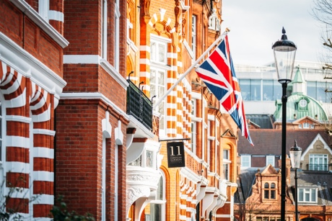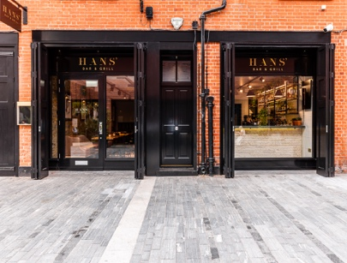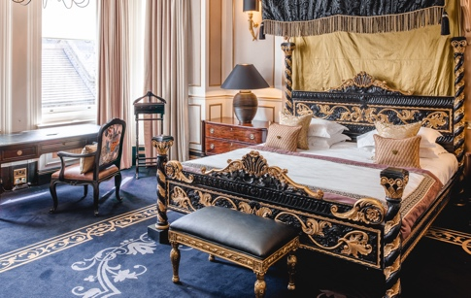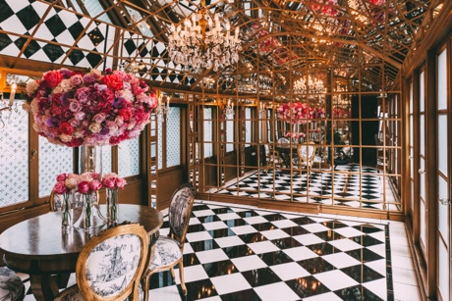

**Media Contacts:**

J Public Relations Iconic Luxury Hotels

[iconic@jpublicrelations.com](mailto:iconic@jpublicrelations.com) [angela@iconicluxuryhotels.com](mailto:angela@iconicluxuryhotels.com)

* **Tucked away behind the heart of Sloane Square** on Chelsea’s leafy Cadogan Gardens, 11 Cadogan Gardens is the ultimate private escape for any traveller and arguably “Chelsea’s best kept secret”.
* **Built by Lord Chelsea in the late 19th century** as part of the prestigious Cadogan Estate, the hotel originally comprised of four Victorian townhouses, which explains the myriad of corridors, staircases and hallways throughout.
* **Opulent, dramatic and decadent** are the style cues that echo around the hotel and a sense of individuality prevails. The property is elegant and refined, yet moody and seductive. Formerly a private members club and haunt of the fashionable upper classes, the hotel is renowned for its privacy and unrivalled luxury.
* **11 Cadogan Gardens’ much loved Hans’ Bar & Grill restaurant delivers a delicious all-day service in a calm and rejuvenating oasis-like setting.** All menus, from breakfast to brunch, lunch, and dinner, are rooted in local British produce.
* **Hans’ Bar & Grill takes inspiration from the restaurant's namesake Sir Hans Sloane**, an iconic Chelsea physician who brought drinking cocoa to the UK from Jamaica, after seeing it as a popular drink with local people. Sloane later sold his recipe to Messrs Cadbury who manufactured chocolate using Sloane's recipe. Chocolate desserts and signature hot chocolate drinks take centre stage on the menu.
* **The Chelsea Bar** in the main townhouse is a moody and seductive bar offering an extensive cocktail menu, specialising in the Negroni. Signatures range from the “Cadogan Negroni” with Campari, Cognac XO, Apricot Liqueur and Peychaud’s Bitters to the “Pickled Negroni” with Lustau Sherry, Campari, and Pickled Grapefruit.
* **The Terrace is a haven hidden from the hustle and bustle** of city lifeavailable to guests to soak up the glorious sunshine during the warmer months (watching Wimbledon is particularly popular in July) while enjoying a chilled glass of Champagne.
* **The Drawing Room** is a welcome retreat for guests, with an eclectic mix of warmly toned fabrics and light floral-patterned walls creating a comfortable and cosy atmosphere in which to relax and indulge in a delectable afternoon tea.
* **The dramatic ‘Alice in Wonderland-esque' Mirror Room** is where guests can capture stunning images to remember their trip. It also doubles as a secret entrance to two Cadogan suites. With floor-to-ceiling mirrors and gold detail, the Mirror Room is 11 Cadogan Gardens’ most photographed room.
* **The Library** is a relaxing and calm space with contemporary furniture and an ornate antler chandelier with shelves lined with an extensive collection of historic and antique books, some dating back to the 19th century. It is the perfect space to retreat during a stay at 11 Cadogan Gardens.
* **Each year in May for Chelsea in Bloom** the property adorns its red brick exterior in themed floral displays. The hotel has previously won Gold for their “Under The Sea” extravaganza, a design overgrown with corals and ocean floor treasures, unusual plant varieties and fresh cut flowers.
* **Several of the suites have private entrances** perfect for high-profile guests seeking the utmost privacy, notably the one-bedroom Cadogan Suites in the mews building which overlook Pavilion Road and boast a separate living room, great for longer stays.
* **The property’s magnificent Sloane Suite** overlooks Cadogan Gardens and epitomises the elegant style and decadence of the 11 Cadogan experience. Guests have their own private entrance, separate lounge area, and for the utmost of space, the suite can be connected to two Signature Suites on the ground floor.
* **Named after Spanish painter, Diego Velázquez, the lavish Velasquez Suite** is the most dramatic suite at the hotel. Swags of heavy velvet and brocade feature throughout, an impressive Murano glass chandelier hangs from the ceiling, a sumptuous four-poster bed stands proudly in the centre, and the distinctive colour palette of red and black defines the romantic interior of this signature suite.
* **In April 2021, the hotel launched The Apartments by 11 Cadogan Gardens** which offer a completely new style of accommodation to the hotel’s existing 56 rooms and suites. Located across the leafy, private Cadogan Gardens and set behind a red brick Victorian façade, The Apartments by 11 Cadogan Gardens consist of six floors, each home to a one, two or three-bedroom elegant residence. Perfect for all – families and business travellers, to larger groups and longer stays.
* **A quintessentially British hotel, 11 Cadogan Gardens is Relais & Châteaux’s first London hotel** and follows in the footsteps of sister hotel Chewton Glen’s which was the first Relais & Châteaux in the UK. Relais & Châteaux is a global fellowship of individually owned and operated luxury hotels and restaurants, with 580 members in 60+ countries around the world. 11 Cadogan Gardens’ sister property The Chelsea Townhouse is the only other London hotel included in the Relais & Châteaux collection.
* **Guests can wander in a few moments to the characterful Pavilion Road, London’s longest mews** that runs parallel to Sloane Street, also the place for artisan food and drink. Formerly Victorian stable blocks, the road has seen a complete transformation and is now a picturesque haven for independent artisans, from butcher and baker to grocer and cheesemonger (and three restaurants).

**11 CADOGAN GARDENS** is owned by Cadogan, whose estate spans 93 acres of Chelsea and Knightsbridge. Built by Lord Chelsea in the late 19th century and originally comprised of four separate Victorian town houses, 11 Cadogan Gardens is Relais & Châteaux’s only London hotel, located in the heart of Chelsea. Throughout its many corridors, the boutique property has 56 guest rooms, including 25 suites that have been designed to be as memorable as they are luxurious, and each completely different. The terrace and conservatory provide the ultimate sunny haven to experience a quintessentially British afternoon tea, whilst the newly launched Hans’ Bar and Grill is perfect for a brief elevenses meet up or intimate late-night dinner. Graced with a traditional Victorian façade and rich in history, heritage, and intrigue, 11 Cadogan Gardens is an unmistakable hotel not to be missed.

2021 saw the opening of The Apartments by 11 Cadogan Gardens, a newly renovated six-storey historic townhouse, which offers a completely new style of accommodation to the hotels existing rooms and suites. Consisting of six fully serviced one, two or three-bedroom elegant residences with the discretion, comfort, and security of a private apartment, they provide a tranquil home-away-from-home for guests looking to experience the best the capital has to offer.

**About Iconic Luxury Hotels**

Iconic Luxury Hotels was founded in December 2016 and is an expanding hotel company with an international focus. The collection of owned and managed hotels comprises an eclectic mix of properties each of which celebrates distinctive architectural style, cultural heritage, and natural surroundings. Each property has its own character, traditions, and stories but they share a common commitment to delivering outstanding experiences.

The current portfolio includes some of the world’s most famous hotels from Cliveden House, one of England’s finest country estates, to the Hotel Excelsior in Italy which is the home of the Venice International Film Festival. The other UK hotels comprise the Chewton Glen, an English estate on the South Coast; The Lygon Arms, a 14th Century Coaching Inn in the Cotswolds; 11 Cadogan Gardens in Chelsea, one of London’s most prestigious residential neighbourhoods; The Mayfair Townhouse which sits in the heart of exclusive Mayfair; and the newest addition to the collection The Chelsea Townhouse, which opened its doors in September 2023. Later this year we will see the opening of the luxurious Palm House Hotel, in Palm Beach, Miami, Florida.

Iconic Luxury Hotels is part of L+R Hotels, a family-owned global hotel investment and management company with an extensive portfolio of more than 115 hotels, with 23,000 bedrooms across the UK, Europe, the US, and the Caribbean. With an evolving collection, ranging from select service hotels in Europe’s most sought-after cities, to opulent, five-star assets and breath-taking leisure resorts, many of which are in the world’s most exclusive locations, including Barcelona, Grand Cayman, Ibiza, London, Los Angeles, Mallorca, Monte Carlo, Turks and Caicos, Venice and more.